[**VISUAL PHYSICS ONLINE**](http://www.physics.usyd.edu.au/teach_res/hsp/sp/spHome.htm)

**THERMODYNAMICS**

**METHODS OF HEAT TRANSFER**

**RADIATION**

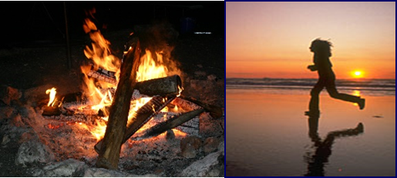

**Radiation** is the energy transferred by electromagnetic waves mainly infrared (IR), visible and ultraviolet (UV). All materials radiate energy in the form of electromagnetic waves in amounts determined by their temperature.

Thermal radiation wavelength ranges

**IR**  ~ (100 - 0. 8) m

**Visible** ~ (0.8 - 0.4) m (800 – 400) nm

**UV** ~ (0.4 - 0.1) m

micrometre 1 m = 1x10-6 m

nanometre 1 nm = 1x10-9-9 m

All objects above **absolute zero** emit radiant energy and the rate of emission increases and the peak wavelength decreases as the temperature of object increases.

Infrared thermography, thermal imaging, and thermal video are examples of infrared imaging science. Thermographic cameras usually detect radiation in the long-infrared range of the electromagnetic spectrum (9–14 µm or 9000–14000 nm) and produce images of that radiation, called **thermograms**.

Since infrared radiation is emitted by all objects with a temperature above absolute zero (**blackbody radiation law**), thermography makes it possible to see one's environment with or without visible illumination. The amount of radiation emitted by an object increases with temperature, therefore, thermography allows one to see variations in temperature. When viewed through a thermal imaging camera, warm objects stand out well against cooler backgrounds; humans and other warm-blooded animals become easily visible against the environment, day or night. Thus, thermography is particularly useful to the military and other users of surveillance cameras.

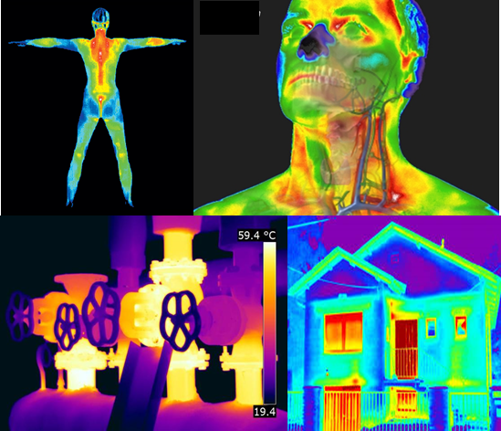

**Electromagnetic Spectrum**

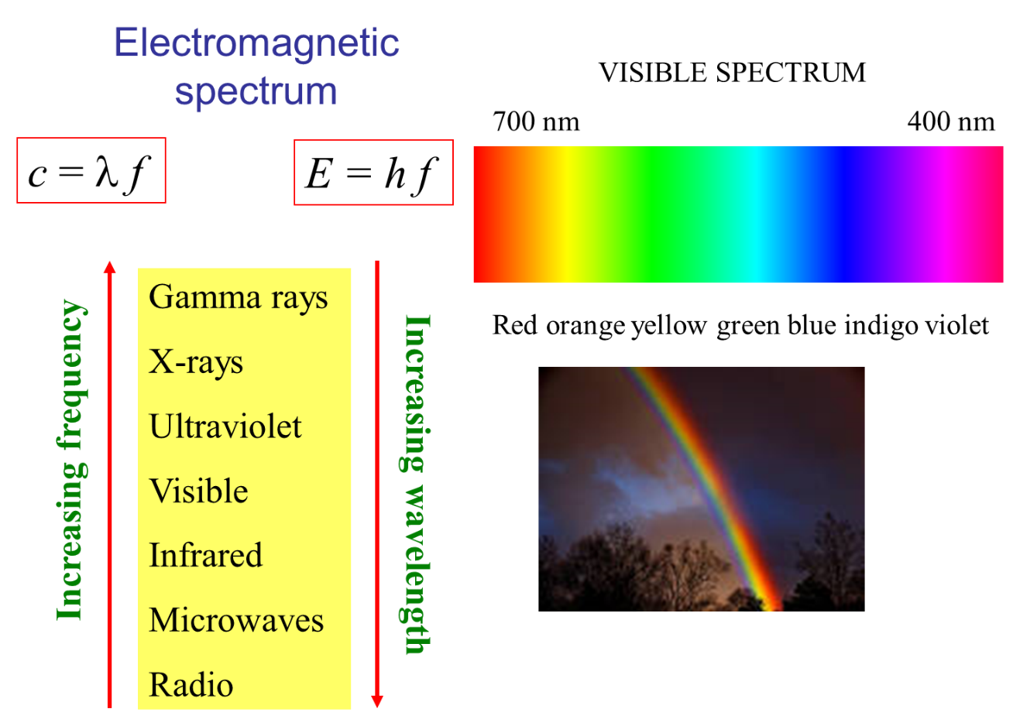

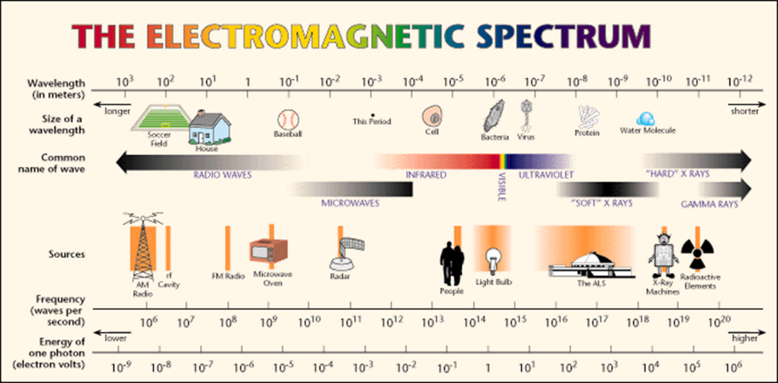

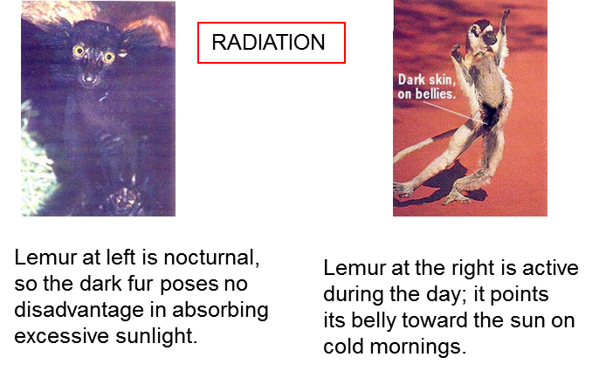

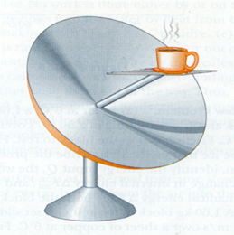

Solar collector

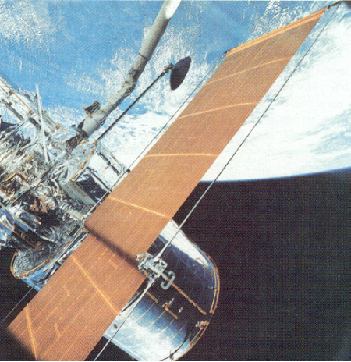

Highly reflecting metal foil keeps inside temperature low

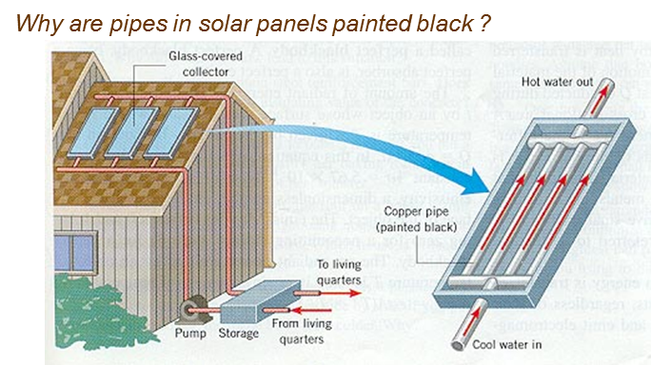

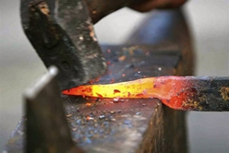

**From the colour of the iron rod taken from a hot fire, what can you conclude about the temperature of different parts of the rod?**

**Radiation Laws**

The Syllabus does not give any equations for the transfer of heat by radiation. So, you don’t need to know the following mathematics, but without this knowledge, you would have a very limited view of fundamental and important ideas related to thermal phenomena.

Every object because of its temperature emits electromagnetic waves. The emission from the surface of an object depends upon the surface area  over which the radiation occurs, the nature of the surface described by the surface emissivity  and the temperature  of the surface. The power  (energy / time) radiated is described by the **Stefan-Boltzmann Law**

 temperature must be in kelvin K

The constant is known as the **Stefan-Boltzmann constant**



Note that the power radiated is proportional to the **fourth** power of the temperature – a small change in temperature leads to a larger change in the power radiated.

The nature of the surface described by the surface emissivity  which is a dimensionless number between 0 and 1 and its value indicates how effective the surface is in radiating energy (or absorbing energy). A value of  is a perfect radiator and the object radiating is called a **blackbody**. Generally, a dark coloured surface has an emissivity near 1, whereas a light-coloured surface has an emissivity must less than 1.

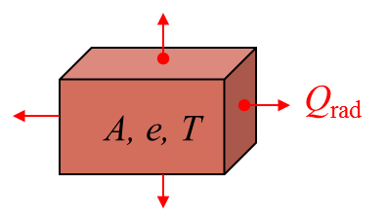

Radiation falling on a surface absorbs that radiation. Therefore, all surfaces are emitting radiation and absorbing it. Thus, if the temperature of a System is  and its surrounding temperature is  the net power  radiated by the object is



If the surface temperature is greater than the surroundings , it radiates more energy that it absorbs, hence, .

If the surface temperature is less than the surroundings , it radiates less energy that it absorbs, hence, .

At equilibrium, where the surface and surroundings are at the same temperature, hence, .

A **blackbody**  is both a perfect radiator and absorber of electromagnetic radiation.

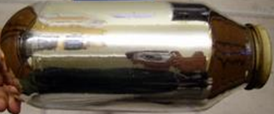The opposite of a blackbody is an **ideal reflector**, which absorbs zero radiation. This is why the inside of a Thermos bottle is highly reflective, very little heat energy is absorbed from the hot contents.

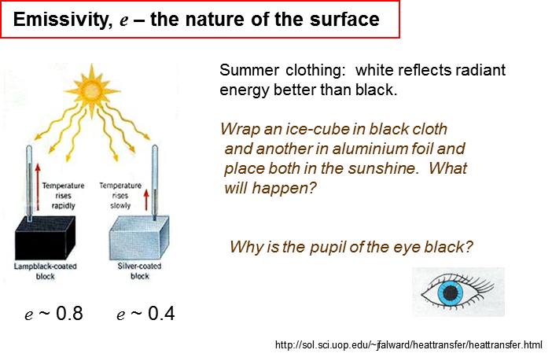

***Thinking question***

Explain the role of the surface of the thermal collector.

To make a solar collector efficient, materials are designed to have a selective surface for the absorption and emission of radiation. The selective surfaces are good absorbers of shortwave radiation (sunlight) and good emitters at longer wavelengths to heat water.

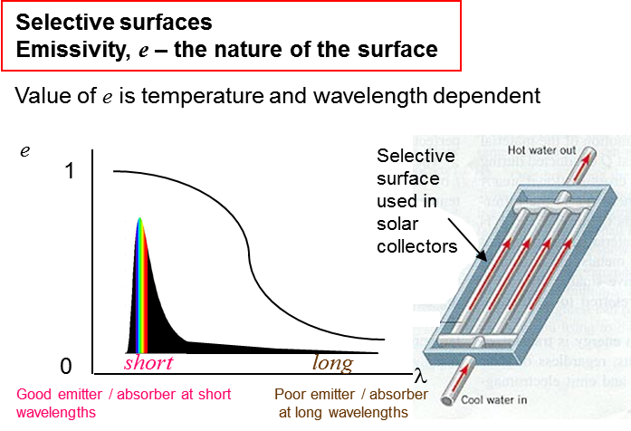

Good emitters of radiation are also good absorbers of radiation and poor emitters are poor absorbers. A good radio antenna is a good transmitters and receiver. A poorly designed antenna is a poor receiver. Absorption and reflection are opposite processes. A good absorber of radiant energy reflects very little energy (including light) and so looks dark. Good reflectors are poor absorbers.



Clean snow is a good reflector and does not melt quickly in sunlight. Dirty snow melts faster because of the greater absorption of sunlight.

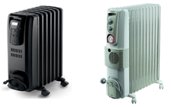Most oil type heaters warm the room by convection and not radiation, so colour should not make any difference. However, for optimum efficiency, a light coloured radiator will radiate less and remain hotter

longer and do a better job in keeping the air warm.

Snow lying on grass melts much more slowly than the snow of the road. Grass is a good insulator and little energy is conducted from the ground through the grass to the snow. However, the road surface conductors more energy, so the snow melts more quickly.



**Wien’s Displacement Law**

A useful law for understanding the radiation emitted from a hot object is **Wien's Displacement Law**. It states that peak wavelength of the radiation emitted from a hot body is inversely proportional to the temperature .

 Wien’s constant 

An interesting graph for the radiation emitted by a blackbody is known as the **blackbody radiation curve** in which the energy radiated is plotted against the wavelength.

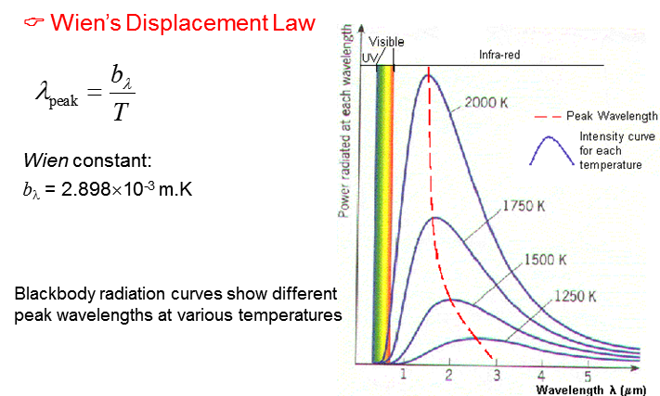

The Sun to a good approximation radiates as a blackbody and its blackbody radiation curve is

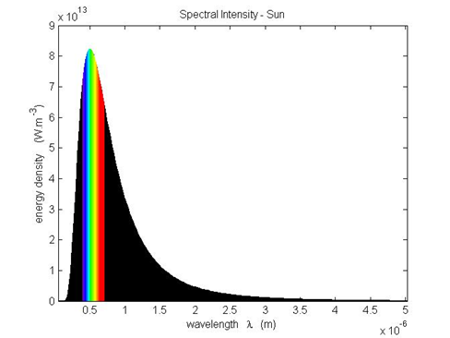

The peak wavelength for the radiation from the Sun is about

 **green ligh**t

From Wien’s Displacement Law, the surface temperature of the Sun is



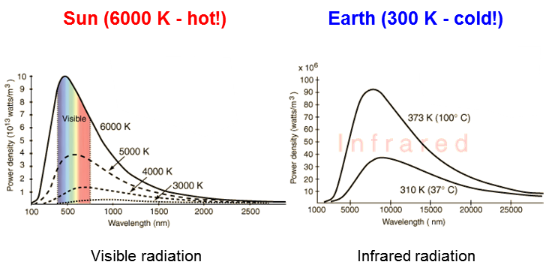

We can state the Wien Displacement law in terms of the peak frequency of the radiant energy



The peak frequency of the radiant energy emitted from an object is proportional to its surface temperature .

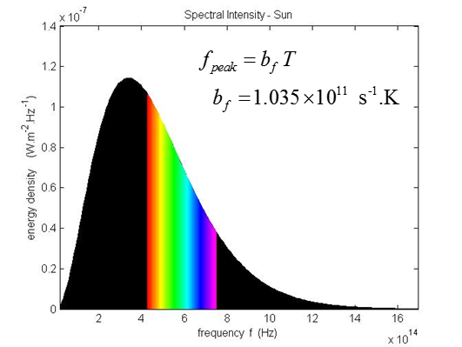

The Sun has a high temperature (~ 6000 K) and most of the

radiation emitted from the Sun is in the visible part of the EMR

spectrum (**solar radiation**). The surface of the Earth is relatively

cool and emits mostly infrared radiation which is called **terrestrial radiation**. The interior of the Earth is warmed by nuclear reactions (radioactive decay). Energy is conducted to the surface from the interior to become terrestrial radiation.

Everyday objects mainly emit infrared radiation. When your

skin absorbs this infrared radiation, you have a warming sensation, for example, when standing in front of a fire.

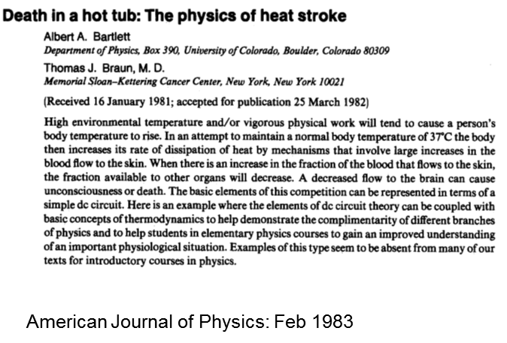

[VISUAL PHYSICS ONLINE](http://www.physics.usyd.edu.au/teach_res/hsp/sp/spHome.htm)

If you have any feedback, comments, suggestions or corrections please email:

Ian Cooper School of Physics University of Sydney

ian.cooper@sydney.edu.au